Directory of Services Capacity Management Process for end users
Overview

The NHS Pathways Directory of Services (DoS) underpins NHS 111, enabling referral to appropriately commissioned services.
The DoS also allows receiving providers to manage their own capacity, either reduce or stop referrals for a period of time or when appointments are full.
The following quick guide will help you to use the capacity tool for your service.

Gaining access to DoS

To access the NHS Pathways Directory of Services, go to http://www.pathwaysdos.nhs.uk and click on the ‘Request an Account’ link.
Then validate your email address and wait for us to approve you and send you a Username and Password.
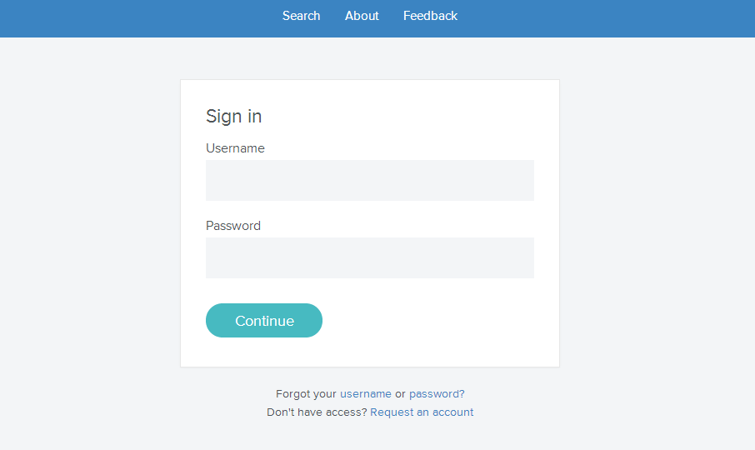

Home page

Once you have entered your login credentials, the DoS will automatically load the home screen. You will then be presented with services for which you have been assigned capacity management control. Click on the service that you wish to manage. It will then load the service.
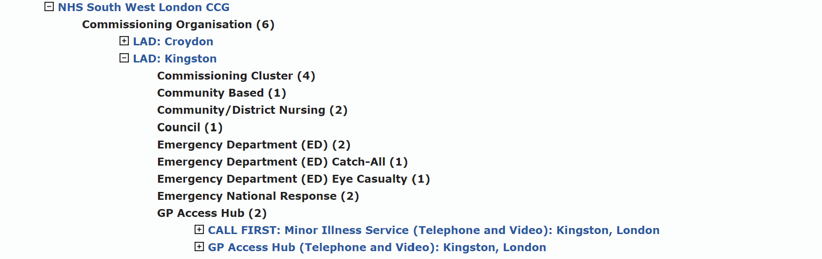
Capacity tool

Once the service profile has loaded for the service you wish to manage, click on the capacity status tab to access the RAG (red, amber green) tool. For more details about capacity status, please see table 1 below.

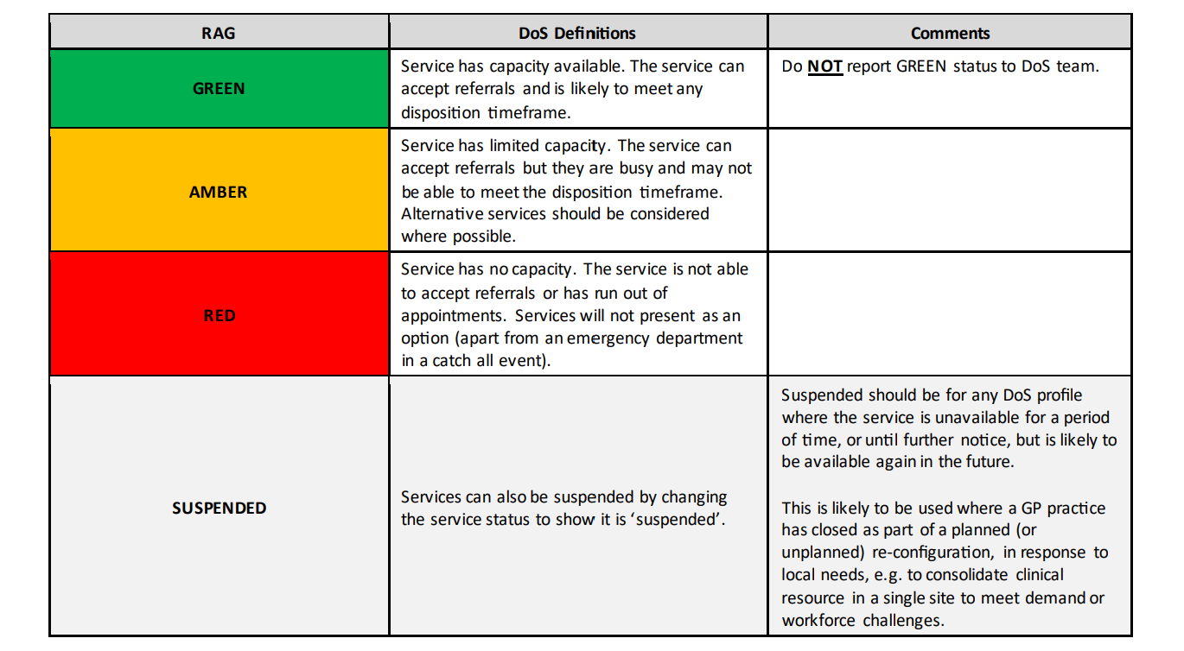
Table 1: Capacity status explanation

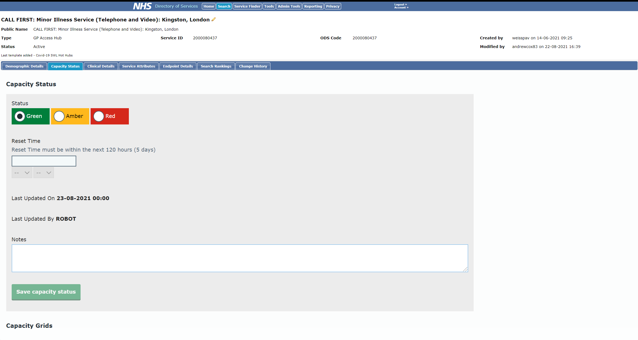
Reset time

Reset time is only available if the service has amber or red capacity. The reset time must be within the next 120 hours (5 days). After selecting the day and time, please move to the next section that is "notes".

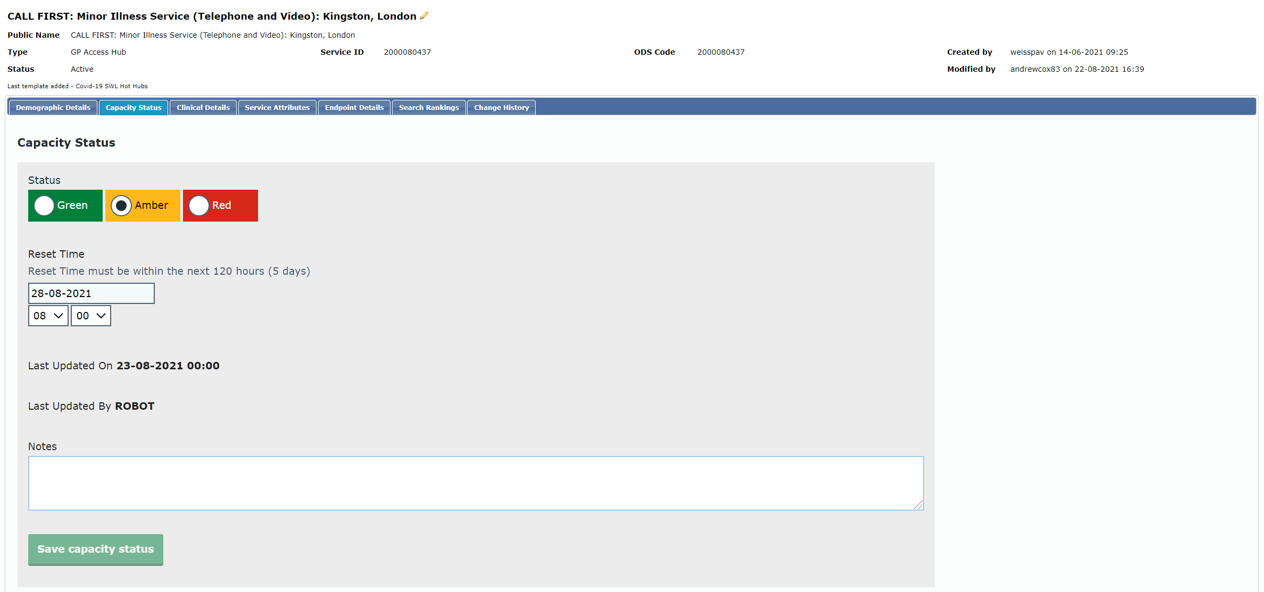
Notes = reason for the capacity amendment

Please make sure you use one of the reasons from table 2 below. You must then copy and paste the reason into your email. This will help with CCG and STP level reporting.
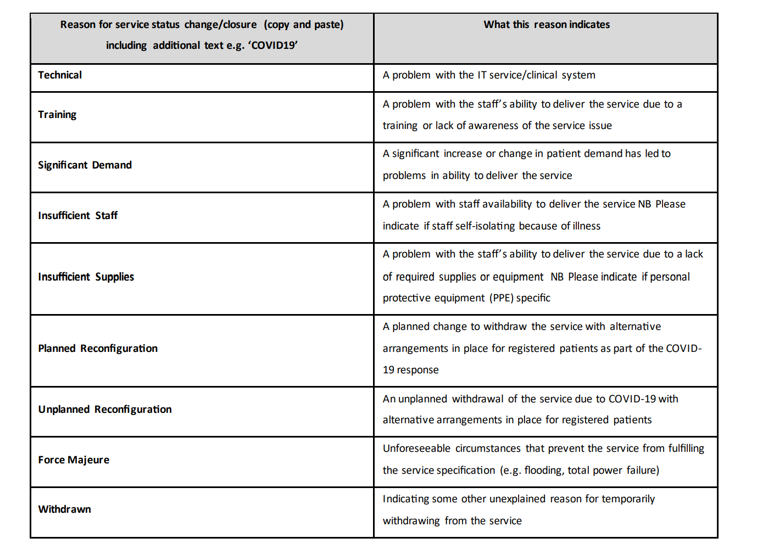
Table 2: Reason for service status change/ closure
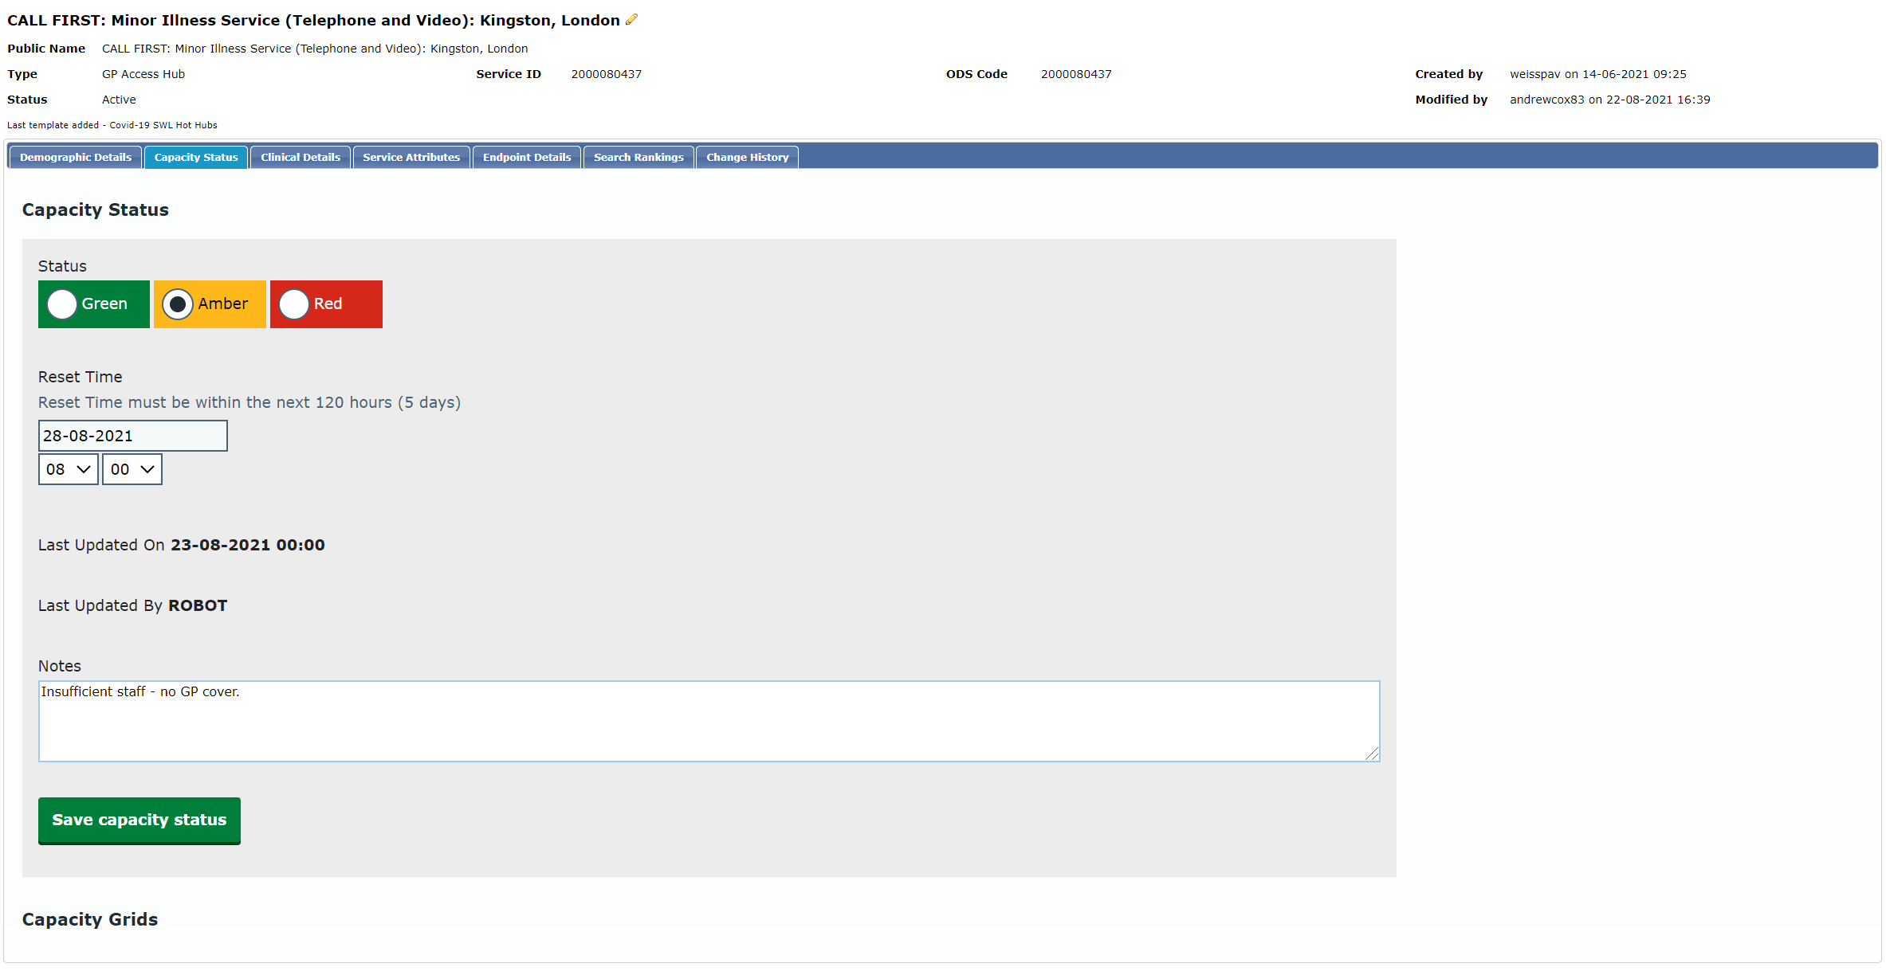
Notify commissioners, NHSE and DoS team

The last and most crucial part is to notify all participants about the change on DoS. These includes
Commissioners, DoS team and HLP/NHSE. Please use the name of the service + reason + status type and reset time as part of the subject to make it easier for all participants to acknowledge the change.

Example - Subject: CALL FIRST: Minor Illness Service (Telephone and Video): Kingston, London - insufficient staff - no GP cover - Amber - 28/08/2021 08:00
Please fill the body of the email and include the following participants:

Commissioners:
Jatinder.Bhuhi@swlondon.nhs.uk
mark.connor3@nhs.net
emily.odonnell@swlondon.nhs.uk
DoS team (In hours):
Pavol.weiss@nhs.net
Folake.oladipo@nhs.net
Nelcsu.dos@nhs.net
HLP/ NHSE (DoS team OOH):
mark.bamlett@nhs.net
andrew.cox2@nhs.net

